

*Business Plan*

*Company:*

*Date:*

***“A cryptocurrency custody solution built for public companies and financial institutional needs with cold storage facilities, security controls, insurance and multi-signature accounts thus giving better protection for their Crypto Assets.”***

**Contact Us**

Name : xxxx

Title : Director

Company : xxxx

Address : TBA

Country : xxxx

Telephone Number : xxxx

Email Address : xxxx

Website : xxxx

xxxx

# Statement of Confidentiality & Non-Disclosure

**© Copyright Biztree Inc. 2010. All rights reserved. Protected by the copyright laws of the United States & Canada and by international treaties. IT IS ILLEGAL AND STRICTLY PROHIBITED TO DISTRIBUTE, PUBLISH, OFFER FOR SALE, LICENSE OR SUBLICENSE, GIVE OR DISCLOSE TO ANY OTHER PARTY, THIS PRODUCT IN HARD COPY OR DIGITAL FORM. ALL OFFENDERS WILL BE SUED IN A COURT OF LAW.**

**© Copyright Biztree Inc. 2010. All rights reserved. Protected by the copyright laws of the United States and Canada and by international treaties. IT IS ILLEGAL AND STRICTLY PROHIBITED TO DISTRIBUTE, PUBLISH, OFFER FOR SALE, LICENSE OR SUBLICENSE, GIVE OR DISCLOSE TO ANY OTHER PARTY, THIS PRODUCT IN HARD COPY OR DIGITAL FORM. ALL OFFENDERS WILL AUTOMATICALLY BE SUED IN A COURT OF LAW.**

This document contains proprietary and confidential information. All data submitted to [RECEIVING PARTY] is provided in reliance upon its consent not to use or disclose any information contained herein except in the context of its business dealings with Xxxxx. The recipient of this document agrees to inform its present and future employees and partners who view or have access to the document's content of its confidential nature.

The recipient agrees to instruct each employee that they must not disclose any information concerning this document to others except to the extent that such matters are generally known to, and are available for use by, the public. The recipient also agrees not to duplicate or distribute or permit others to duplicate or distribute any material contained herein without Xxxxx's express written consent.

Xxxxx retains all title, ownership and intellectual property rights to the material and trademarks contained herein, including all supporting documentation, files, marketing material, and multimedia.

BY ACCEPTANCE OF THIS DOCUMENT, THE RECIPIENT AGREES TO BE BOUND BY THE AFOREMENTIONED STATEMENT.

|  |  |
| --- | --- |
| ...........................................................  *Signature*  **Name:** [Client name]  **Date:** 00/00/0000 | ............................................................  *Signature*  **Name:** [Your name]  **Date:** 00/00/0000 |

# Executive Summary

## Introduction

**© Copyright Biztree Inc. 2010. All rights reserved. Protected by the copyright laws of the United States & Canada and by international treaties. IT IS ILLEGAL AND STRICTLY PROHIBITED TO DISTRIBUTE, PUBLISH, OFFER FOR SALE, LICENSE OR SUBLICENSE, GIVE OR DISCLOSE TO ANY OTHER PARTY, THIS PRODUCT IN HARD COPY OR DIGITAL FORM. ALL OFFENDERS WILL BE SUED IN A COURT OF LAW.**

**© Copyright Biztree Inc. 2010. All rights reserved. Protected by the copyright laws of the United States and Canada and by international treaties. IT IS ILLEGAL AND STRICTLY PROHIBITED TO DISTRIBUTE, PUBLISH, OFFER FOR SALE, LICENSE OR SUBLICENSE, GIVE OR DISCLOSE TO ANY OTHER PARTY, THIS PRODUCT IN HARD COPY OR DIGITAL FORM. ALL OFFENDERS WILL AUTOMATICALLY BE SUED IN A COURT OF LAW.**

The purpose of this Business Plan is to seek investor funding for our business. The plan outlines our business model in depth in respect to the market and customer need for our product/service, our strategies to go to market, financial rewards to you and our business, future opportunities for this business and why we are the best choice to manage this business model.

## The Problem and our Solution

Crypto Assets represent the next great evolution of money, the digital economy and are transforming industries. The blockchain technology that is powering the crypto market is also evolving and creating new opportunities across the world to build solutions to better serve this rapidly growing markets. At this stage the market is still in the new to mature stage as customers and financial institutions slowly adopt to these new currencies. Consequently, there are many problems in the market place associated with crypto assets such as:

* Crypto assets are sitting in an unregulated market.
* The crypto assets are typically not uninsured.
* Crypto assets are frequently subject to hacking from external sources.
* Subject to loss (physical hardware).
* There is no central distribution control.

The solution that we are offering to our customers is to provide a regulated and insured cold (offline) storage of crypto assets (Bitcoin, Ethereum & etc.) in a duly qualified Xxxxx afforded full protection on the law. The solution will give our customers the deserved peace of mind that that their assets are in good hands.

## Company Goals/Objectives

The business has determined that the following major objectives are critical for long-term sustainability and viability. Each of the major objectives contains sub-objectives. The company will regularly monitor these objectives to ensure that they are adequate for the present model.

* To build a sustainable business model for long-term financial benefits for its shareholders and employees.
* To develop and maintain the highest quality Crypto Asset Storage.
* To maintain a high level of customer service.
* World class security

## Keys to Success

Our successful operation of the business model will depend upon our ability to achieve the following success factors:

* Acquire the funding to commence the business.
* To gain and maintain regulatory approval for the business.
* Adoption of the crypto by our customers.
* Successful marketing targeted to the type of customer.
* To be the 1st mover advantage and acquire significant market share

## Market

Cryptocurrencies are likely to become a critical component of the world’s digitized and global economy in the 21st century. As can be seen, the cryptocurrency market seems to be growing in popularity every day. 2017 was a record year for the launch of new cryptocurrency funds with over 150 new funds including hedge funds and venture capital. This was more than triple the number of funds launched in 2016. It’s possible there will be as many as 200 crypto fund launches in 2018 based on the current pace.

Cryptocurrency remains a volatile asset, although products and services linked to its servicing are increasing rapidly. The number of wallets sold has increased rapidly, an average 18% per year since 2015, and current trends suggest that even at a conservative rate, the market will likely increase at a rate of 10-15% per year through to 2019 (see charts below; projections are based on an average +10% y/y relative to the 18% average growth seen between 2015-17

## Competition

**© Copyright Biztree Inc. 2010. All rights reserved. Protected by the copyright laws of the United States & Canada and by international treaties. IT IS ILLEGAL AND STRICTLY PROHIBITED TO DISTRIBUTE, PUBLISH, OFFER FOR SALE, LICENSE OR SUBLICENSE, GIVE OR DISCLOSE TO ANY OTHER PARTY, THIS PRODUCT IN HARD COPY OR DIGITAL FORM. ALL OFFENDERS WILL BE SUED IN A COURT OF LAW.**

**© Copyright Biztree Inc. 2010. All rights reserved. Protected by the copyright laws of the United States and Canada and by international treaties. IT IS ILLEGAL AND STRICTLY PROHIBITED TO DISTRIBUTE, PUBLISH, OFFER FOR SALE, LICENSE OR SUBLICENSE, GIVE OR DISCLOSE TO ANY OTHER PARTY, THIS PRODUCT IN HARD COPY OR DIGITAL FORM. ALL OFFENDERS WILL AUTOMATICALLY BE SUED IN A COURT OF LAW.**

There are four major competitors in the market place being Fidelity, BitGo, Coinbase and Xapo. Each competitor offers a similar range of services but generally they lack the full service that our business model offers to our customers.

Our competitive advantage is that no other company offers exclusively institutional quality, fully insured crypto custodial services.

## Management Team

**© Copyright Biztree Inc. 2010. All rights reserved. Protected by the copyright laws of the United States & Canada and by international treaties. IT IS ILLEGAL AND STRICTLY PROHIBITED TO DISTRIBUTE, PUBLISH, OFFER FOR SALE, LICENSE OR SUBLICENSE, GIVE OR DISCLOSE TO ANY OTHER PARTY, THIS PRODUCT IN HARD COPY OR DIGITAL FORM. ALL OFFENDERS WILL BE SUED IN A COURT OF LAW.**

**© Copyright Biztree Inc. 2010. All rights reserved. Protected by the copyright laws of the United States and Canada and by international treaties. IT IS ILLEGAL AND STRICTLY PROHIBITED TO DISTRIBUTE, PUBLISH, OFFER FOR SALE, LICENSE OR SUBLICENSE, GIVE OR DISCLOSE TO ANY OTHER PARTY, THIS PRODUCT IN HARD COPY OR DIGITAL FORM. ALL OFFENDERS WILL AUTOMATICALLY BE SUED IN A COURT OF LAW.**

The management of the business is based upon a small skilled and experienced team that has many years industry experience within the financial institution industry. Ms. Serra Angel Wei “Serra” is the Founder & CEO at AegisCo. Mr. Charles A. Christofilis will be the President of the Xxxxx. Most of the internal functions of the Trust company will be outsourced initially until the company has achieved significant growth to bring functions in-house. The biographies of the management team are shown later in this Plan.

## Key Opportunities & Risks

### Key Opportunities

The company has three main opportunities for the future. These opportunities are:

1. Growth of crypto as an asset class,
2. Adoption of cryptocurrency
3. Franchising the business model.

### Key Risks

All businesses are exposed to risks on a daily basis regardless of its life-cycle. It is how the risks are reviewed, monitored and managed that will determine viability and sustainability. The company has identified the following four key risks:

|  |  |
| --- | --- |
| **Risk** | **Risk Minimization Strategy** |
| Lack of investor funding | Seek alternate forms of financing. This will delay the commencement of the project. |
| Changes in the regulatory environment | SD Trust Company License / registration |
| Hacking into company data from external sources | Better technology (Multi Signature –  cold (offline) storage) |
| Value of crypto which is dominated by market forces. | Long term time horizon and increasing  obsolescence and worthlessness of  government sponsored currencies |

The company will have in place sufficient and adequate risk management strategies that will keep the risks minimized at all times

## Financial Summary

**Highlights**

* Fifth year revenue to reach $xx million based upon Assets Under Management of $xx billion.
* Net profit before tax of 74% in fifth year.
* Return on Investment after dividends = 124%
* Strong cash position by end of fifth year of $xx million.

**Assumptions**

* 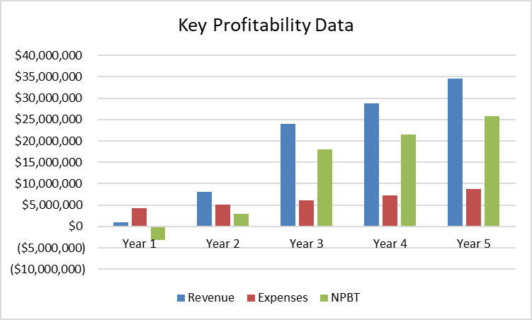As the business grows, overheads are projected to increase by 20% per annum.
* Revenue service fee is expected to decline in future years due to heavy competition in the market place.

## Funding Requirements

The company requires US$XX million to commence this business model. The funding will predominantly be used to meet net capital needs (US$xx,000,000) and working capital requirements (US$xx,000,000).

## Investor Return

We invite a single or group of investors to partner with us along our exciting journey. The matrix for invitation to our business model will look similar to the table below.

|  |  |  |
| --- | --- | --- |
| **Invitation** | **% Equity each shareholder** | **% of dividends each shareholder paid out of after-tax profits** |
| 1 Shareholder | 75% | 30% |
| 5 Shareholders | 15% | 6% |
| 10 Shareholders | 7.5% | 3% |

## Exit Strategy

We encourage our investor(s) to be with us for at least five years. The company has no immediate plans for exiting. The company plans to be still trading in ten years’ time allowing it the opportunity to expand its business model into other locations across the country. The strength of the Balance Sheet will allow the business to be in a strong position for takeover, seeking further funding or for the directors to exit the business. The exit strategies to be considered will be either a Merger and Acquisition or Initial Public Offering (IPO).

**Table of Contents**

**© Copyright Biztree Inc. 2010. All rights reserved. Protected by the copyright laws of the United States & Canada and by international treaties. IT IS ILLEGAL AND STRICTLY PROHIBITED TO DISTRIBUTE, PUBLISH, OFFER FOR SALE, LICENSE OR SUBLICENSE, GIVE OR DISCLOSE TO ANY OTHER PARTY, THIS PRODUCT IN HARD COPY OR DIGITAL FORM. ALL OFFENDERS WILL BE SUED IN A COURT OF LAW.**

**© Copyright Biztree Inc. 2010. All rights reserved. Protected by the copyright laws of the United States and Canada and by international treaties. IT IS ILLEGAL AND STRICTLY PROHIBITED TO DISTRIBUTE, PUBLISH, OFFER FOR SALE, LICENSE OR SUBLICENSE, GIVE OR DISCLOSE TO ANY OTHER PARTY, THIS PRODUCT IN HARD COPY OR DIGITAL FORM. ALL OFFENDERS WILL AUTOMATICALLY BE SUED IN A COURT OF LAW.**



Statement of Confidentiality & Non-Disclosure 3

Executive Summary 4

Introduction 4

The Problem and our Solution 4

Company Goals/Objectives 4

Keys to Success 4

Market 5

Competition 5

Management Team 5

Key Opportunities & Risks 6

Financial Summary 6

Funding Requirements 7

Investor Return 7

Exit Strategy 7

1. Business Description 10

1.1 Company Description 10

1.2 Core Values 10

1.3 Goals and Objectives 11

1.4 Critical Success Factors 11

1.5 SWOT Analysis 11

2. Products / Services 13

2.1 The Business Model 13

2.2 Crypto Assets 13

2.3 Unique Features of the Crypto Asset Model 14

2.4 Assets Under Management 15

3. The Market 16

3.1 Industry and Market Analysis 16

3.2 Porter’s Five Forces Analysis 18

3.3 Pestle Analysis 20

3.4 Major Competitors 20

4. Marketing Strategies and Sales 24

4.1 Marketing Objectives 24

4.2 Targeting Strategy 24

4.3 Positioning Strategy 24

4.4 Pricing Strategy 24

4.5 Distribution Channels 24

4.6 Promotional Strategy 25

4.7 Sales Forecasts 25

5. Development 26

5.1 Development Strategy 26

5.2 Development Timeline 26

6. Management 27

6.1 Company Organization 27

6.2 Professional Advisors 28

7. Operations 29

7.1 Operations Strategy 29

7.2 Personnel 29

7.3 Risk Management 29

7.4 Operations Expenses 30

7.5 Legal Environment 30

8. Financials 31

8.1 Financial Summary 31

8.2 Key Performance Indicators 32

8.3 Key Ratios 32

8.4 Start-up Funds 32

8.5 Statement of Financial Position (Balance Sheet) 33

8.6 Income Statement 34

8.7 Statement of Cash Flows 35

9. Funding Request 36

9.1 Offer 36

9.2 Capital Requirements 36

9.3 Valuation of Business 37

9.4 Exit Strategy 37

# 1. Business Description

## 1.1 Company Description

Xxxxx will be registered as a privately-owned trust company that will be owned by the public. The company will be a private company holding the assets of its customers. The Corporation will be registered as a Trust Company (registration number TBD) with ownership held by xx. The company will be named “xx” and will be recognised as an institutional Crypto Asset Trust Company.

**Key Facts**

Company Name: Xxxxx (xx)

Registered Address: TBA

Shareholders: 75% xx, 25% xx

Directors: There will be five (5) directors of the Trust Company. The names of the directors will be advised in due course.

## 1.2 Core Values

The company’s business model will be developed around the following four core values of integrity, transparency, fair dealing and responsiveness.

The above core values can be sub-divided into smaller core values:

* Instil a company culture that is rewarding for our small team
* Operate with honesty, integrity and transparency at all times
* Develop healthy relationships with our network of contractors
* Think as a team - Work as a team - Grow as a team
* Focus on positive, action-oriented thoughts

## 

## 1.3 Goals and Objectives

**Vision and Mission Statements**

Our **VISION** is targeted to be the biggest and the best institutional Crypto Asset Trust Company. Our vision will be achieved through the maintenance of our core values.

Our **MISSION** is to be the to be the premier crypto custodian by offering excellent customer service, the delivery of fair value in each and every transaction. The mission can only be achieved through the team culture delivering the easy crypto products to our clients.

The business has determined that the following major objectives are critical for long-term sustainability and viability. Each of the major objectives contains sub-objectives. The company will regularly monitor these objectives to ensure that they are adequate for the present model.

* To build a sustainable business model for long-term financial benefits for its shareholders and employees.
* To develop and maintain the highest quality Crypto Asset Storage.
* To maintain a high level of customer service.
* World class security

## 1.4 Critical Success Factors

Our successful operation of the business model will depend upon our ability to achieve the following success factors:

* Acquire the funding to commence the business.
* To gain and maintain regulatory approval for the business.
* Adoption of the crypto by our customers.
* Successful marketing targeted to the type of customer.
* To be the 1st mover advantage and acquire significant market share.

## 1.5 SWOT Analysis

**© Copyright Biztree Inc. 2010. All rights reserved. Protected by the copyright laws of the United States and Canada and by international treaties. IT IS ILLEGAL AND STRICTLY PROHIBITED TO DISTRIBUTE, PUBLISH, OFFER FOR SALE, LICENSE OR SUBLICENSE, GIVE OR DISCLOSE TO ANY OTHER PARTY, THIS PRODUCT IN HARD COPY OR DIGITAL FORM. ALL OFFENDERS WILL AUTOMATICALLY BE SUED IN A COURT OF LAW.**

**© Copyright Biztree Inc. 2010. All rights reserved. Protected by the copyright laws of the United States & Canada and by international treaties. IT IS ILLEGAL AND STRICTLY PROHIBITED TO DISTRIBUTE, PUBLISH, OFFER FOR SALE, LICENSE OR SUBLICENSE, GIVE OR DISCLOSE TO ANY OTHER PARTY, THIS PRODUCT IN HARD COPY OR DIGITAL FORM. ALL OFFENDERS WILL BE SUED IN A COURT OF LAW.**

The overall aim of a SWOT analysis is to identify strengths, which can be matched with opportunities, and similarly to identify weaknesses, which should be monitored. The company’s strengths and weaknesses are controlled internally whilst opportunities and threats are external drivers that can impact upon the business. The company has identified its own **SWOT** as outlined below.

**Internal Factors**

**Strengths -** Our strengths are the unique points that differentiate us from our competitors. Our main strength will be the experienced team supporting this business model.

**Weaknesses –** Our major weaknesses are two-fold (a) lack of initial funding to start this valued project and (b) the project is new to the market and thus requires a lot more effort to change customer’s perception on crypto asset storage.

**External Factors**

**Opportunities -** Our biggest opportunity will allow us to look at franchising our business model across the globe and develop the platform for local city and regional communities. Other key opportunities include adoption of crypto plus growth in crypto as an asset class.

**Threats -** Our business must take note of the broad industry shifts that can affect our business and company growth. Legal and regulatory changes can have significant threat to our business.

|  |  |
| --- | --- |
| Helpful  To achieving the objective | Harmful  To achieving the objective |
| **STRENGTHS**   * Advantages of proposition * Capabilities * Competitive advantages * Unique Selling Points * Experience management team and employees * Financial reserves * Location and geographical * Price, value, quality | **WEAKNESSES**   * Customer adoption to crypto currency * Gaps in capabilities * Lack of competitive strength as new to market. * Lacking initial funding * Own known vulnerabilities * Cash-flow * Accreditations |
| **OPPORTUNITIES**   * Market developments * Competitors' vulnerabilities * Growth of crypto as an asset class * Global influences * New markets, vertical, horizontal * Niche target markets * Business and product development * Partnerships, agencies, distribution * Adoption of crypto | **THREATS**   * Political effects * Legislative effects * Regulatory approval * Competitor intentions * Market demand * New technologies, services * Vital contracts and partners * Loss of key staff * Sustainable financial backing |

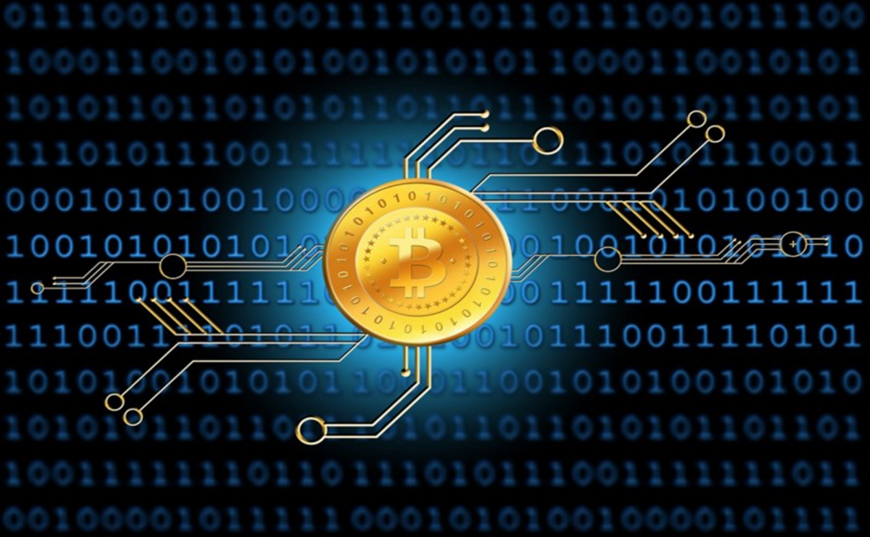

# 2. Products / Services

## 2.1 The Business Model

**© Copyright Biztree Inc. 2010. All rights reserved. Protected by the copyright laws of the United States & Canada and by international treaties. IT IS ILLEGAL AND STRICTLY PROHIBITED TO DISTRIBUTE, PUBLISH, OFFER FOR SALE, LICENSE OR SUBLICENSE, GIVE OR DISCLOSE TO ANY OTHER PARTY, THIS PRODUCT IN HARD COPY OR DIGITAL FORM. ALL OFFENDERS WILL BE SUED IN A COURT OF LAW.**

**© Copyright Biztree Inc. 2010. All rights reserved. Protected by the copyright laws of the United States and Canada and by international treaties. IT IS ILLEGAL AND STRICTLY PROHIBITED TO DISTRIBUTE, PUBLISH, OFFER FOR SALE, LICENSE OR SUBLICENSE, GIVE OR DISCLOSE TO ANY OTHER PARTY, THIS PRODUCT IN HARD COPY OR DIGITAL FORM. ALL OFFENDERS WILL AUTOMATICALLY BE SUED IN A COURT OF LAW.**

There are structural and functional issues that affect the market. These problems stem from a variety of reasons such as the infant nature of the market, lack of understanding of the cryptocurrency space, and some peculiar economics of cryptocurrencies.

* Crypto assets are sitting in an unregulated market.
* The crypto assets are typically not uninsured.
* Crypto assets are frequently subject to hacking.
* Subject to loss (physical hardware).
* There is no central distribution control.

The solution that we are offering to our customers is to provide a regulated and insured cold (offline) storage of crypto assets (Bitcoin, Ethereum & etc.) in a duly qualified Xxxxx afforded full protection on the law. Our primary business is the custody of crypto assets, as we see a great need for this based upon the lack of trusted custody service for crypto combined with the need for publicly traded companies and financial intuitions to have their crypto assets kept in a safe place.

## 2.2 Crypto Assets

A close up of a logo

Description generated with high confidenceA crypto asset is a digital asset which utilises cryptography, peer-to-peer networking, and a public ledger to regulate the creation of new units, verify transactions, and secure the transactions without the intervention of any middleman.

According to BABB, there are four types of crypto assets. [1]

1. Cryptocurrencies
2. Platform tokens/cryptocommodities
3. Utility tokens
4. Transactional tokens

Cryptocurrencies are the most well-known type of crypto-asset. Examples include Bitcoin, Litecoin and Dash. These were created to act as a decentralised alternative to fiat currency which could be easily transacted across the world. Their value fluctuates based on the forces of demand and supply, much like traditional fiat currencies. Although it was intended as a mean of payment, Bitcoin is now considered more of a ‘digital gold’ due to its scarce supply.

A picture containing text, map

Description generated with very high confidence

## 2.3 Unique Features of the Crypto Asset Model

Given the complex needs institutions have due to legal and regulatory frameworks in different jurisdictions, our total solution and product(s) will need to be a suite of hardware and service solutions that we can offer to our customers.

Listed below are some of the unique features about our business model that are needed to be in place before we can market our business model to our customers:

* Distributed and tiered key management policy system that allows the public company or financial institution to set up their own internal control processes to ensure the safeguarding of their crypto assets.
* Multi-signature access to crypto assets thus reducing the risk of theft.
* Storage of crypto assets are kept in cold storage (95%) and warm storage (5%). Warm storage allows the customer to quickly gain access for their liquidity purposes. Cold storage ensures security and safety even in the case of disaster.
* Acceptance of the most commonly-used cryptocurrencies, including Bitcoin, Ethereum, Litecoin, and more. More cryptocurrencies will be added in the future when there is sufficient demand.
* Easy to read report showing movements in and out of crypto assets.
* Our systems are compliant with financial regulators.
* Independent security audits and publish them to ensure clients are getting the most secure solution for their needs
* Operational controls & procedures
* Personnel procedures around security and access to customers’ digital assets

Our crypto asset business model stores private keys of qualified and institutional investors. The storage is secure both physically and digitally on the highest grade hardware security modules with detailed configuration possibilities for individual and role-based access control. This enables flexible multi-signature schemes in addition to native blockchain-specific features. Our solution helps institutional financial intermediaries both domestic and across the globe with the most secure storage solution for crypto and blockchain-based assets to date. It will be an integrated hybrid hardware-software custody with off-chain and on-chain capabilities suitable for various activities that need to be performed. An ability to trade multiple tokens to provide liquidity to the institutional customers and their portfolios.

Our model will allow for highly configurable access to a customer’s crypto assets with institutional-grade access control rules. The private keys never leave the hardware security module (HSM) and the HSM's right to sign a transaction is determined through approval from a configurable quorum within the customer’s organization and executed on tamper-proof approval clients. The solution is highly adjustable to the customer’s internal processes and roles, while maintaining high security behind several layers of hardware protection.

## 2.4 Assets Under Management

Our five year financial projections illustrates that our objective is to growing our crypto asset under management base to US$xx billion within 5 years.

|  |  |  |  |  |  |
| --- | --- | --- | --- | --- | --- |
|  | **Year 1** | **Year 2** | **Year 3** | **Year 4** | **Year 5** |
| Assets under Management | xx | Xx | Xx | Xx | Xx |
|  |  |  |  |  |  |

# 3. The Market

## 3.1 Industry and Market Analysis

Cryptocurrencies are likely to become a critical component of the world’s digitized and global economy in the 21st century. As can be seen, the cryptocurrency market seems to be growing in popularity every day. With the astronomical rise of cryptocurrencies like Bitcoin and Ethereum, there seems to be an influx of people into the market. Many cryptocurrency exchanges cannot even afford to have their account creation feature open all the time. Such is the demand for entry into the market that trading account creation for new customers is periodically disabled.

While the Financial Stability Board believes that crypto-assets do not pose a material risk to global financial stability at this time, it recognises the need for vigilant monitoring in light of the speed of market developments. The monitoring framework focuses on the transmission channels from crypto-asset markets that may give rise to financial stability risks. Monitoring the size and growth of crypto-asset markets is critical to understanding the potential size of wealth effects, should valuations fall. The use of leverage, and financial institution exposures to crypto-asset markets are important metrics of transmission of crypto-asset risks to the broader financial system. The framework also includes metrics on trading volumes, pricing, clearing and margining for crypto-asset derivatives. [2]

2017 was a record year for the launch of new cryptocurrency funds with over 150 new funds including hedge funds and venture capital. This was more than triple the number of funds launched in 2016. It’s possible there will be as many as 200 crypto fund launches in 2018 based on the current pace. In addition to the launch of new VC and crypto hedge funds, it is expected that existing hedge funds to incorporate cryptocurrencies in their portfolios. Likewise, existing VC firms will continue to add blockchain investments as well as launch separate blockchain funds.

### Market Segmentation and Target Market

The market is segmented between cryptocurrency funds, blockchain funds, or digital asset funds. The market can also by segmented in other ways too.

On the basis of end-user, Cryptocurrency market can be segmented into BFSI, retail, media & entertainment, gaming industry, healthcare, travel & tourism, transportation & logistics and education.

On the basis of region, Cryptocurrency market can be segmented into North America, Latin America, and other countries.

### Target Market

Our target market is domestic and foreign (non-US) financial institutions plus domestic public companies. Our business model will be operated at a wholesale channel only and will not be offered as retail channel.

### Market Size and Trends

The average daily trading volume of the market is usually in trillions of dollars. The total market cap of the entire market stands at more than half a trillion dollars which is an astonishing feat considering the market is less than a decade old.

The number of crypto funds is on the rise. With rising prices and rising public awareness, there were more than 100 crypto funds launched in 2017. For comparison, there were about 700 total hedge funds launches in this same time. While accounting for 14% of new hedge fund launches may not seem like much, consider that crypto funds have less than .1% of total hedge funds assets. In fact, crypto hedge funds are the fastest growing segment of the hedge fund industry. In addition, several of the top performing hedge funds in 2017 were cryptocurrency funds. [3]

According to Crypto Funds Research, the number of firms that have Assets Under Management are heavily weighted to the lower end of the scale with assets under management of less than US$10 million.

A screenshot of a cell phone

Description generated with very high confidence

Hedge funds are the most common type of digital asset fund, but venture capital crypto funds are launching quickly, and existing tech/FinTech VC firms are expanding investments into blockchain startups and launching their own blockchain funds. As some blockchain companies mature, private equity funds are beginning to get involved. Hybrid funds – those funds investing in cryptocurrencies as well as initial coin offerings, are listed above as hedge funds although they take on some characteristics of venture funds.

### Market Needs

As demand for cryptocurrency grows, demands for storing it and managing it are growing even more. Bitcoin was amongst the top 90 currencies in the world in early 2017, and by the end of 2017, Bitcoin evolved into the 30th largest currency in the global market, with an exponential increase in user base, daily transaction volume, and trading volumes.

### Market Growth

Cryptocurrency remains a volatile asset, although products and services linked to its servicing are increasing rapidly. The number of wallets sold has increased rapidly, an average 18% per year since 2015, and current trends suggest that even at a conservative rate, the market will likely increase at a rate of 10-15% per year through to 2019 (see charts below; projections are based on an average +10% y/y relative to the 18% average growth seen between 2015-17. [4] At this pace, the number of wallets needed to complete is projected to reach these transactions is roughly 35 million by early 2019, up 6 million from today.

Crypto Funds Research states that the crypto fund industry has been growing rapidly. Changes in assets are a result of three primary factors: the launching of new crypto funds, net inflows to existing funds, and changes in the value of portfolio assets. The latter factor was particularly prevalent in the last half of 2017 when Bitcoin, for example, increased in value nearly fourfold. It’s possible there could be continued contraction in total crypto assets during parts of 2018 as cryptocurrency prices fell off of the all-time highs reached in the beginning of 2018.

A screenshot of a map

Description generated with very high confidence

## 3.2 Porter’s Five Forces Analysis

**Porter's five forces** include three **forces** from 'horizontal' competition--the threat of substitute products or services, the threat of established rivals, and the threat of new entrants--and two others from 'vertical' competition--the bargaining power of suppliers and the bargaining power of customers.

When we take the traditional financial industry as a focal industry, you’ll find that all five forces have low power, thus leading to low overall rivalry. This is because:

* It’s hard to obtain a banking license (force: new entrants)
* Customers cannot exert influence on financial products (power of buyers)
* Banks use very little (asset) suppliers and are not solely dependent on them (power of suppliers)
* Everybody is dependent on fiat currency (threat of substitutes), and
* There are only a few major players that hold majority of power — the ‘big banks’ (degree of rivalry)

We can see that 4 out of 5 forces now have a HIGH power:

* Everyone can join (just look at the amount of ICOs launched every day) and obtaining a banking license is easier than ever (at least in the US, EU and UK) (threat of new entrants)
* Customers are in control and decide which currency to buy and pay with — without any middlemen activity. Also, they control where to store, protect and/or grow their assets. Look, for example, at the amount of wallet providers out there (power of buyers)
* Direct payment solutions and crypto currencies ARE the substitute for traditional banking solutions and FIAT currencies (threat of substitutes)
* Because of all above mentioned reasons, rivalry is bigger than ever, allowing for a healthy market place of supply and demand (degree of rivalry)

**Rivalry**

Factors affecting the intensity of rivalry are:

* Number of firms – more firms will lead to increased competition.
* Fixed costs – with high fixed costs as a percentage of total cost, companies must sell more products to cover those costs, increasing market competition.
* Product differentiation – Products that are relatively the same will compete based on price. Brand identification can reduce rivalry.

**Entry**

Industries with high barriers to entry are usually too expensive for new firms to enter. Industries with low barriers to entry, are relatively cheap for new firms to enter.

The threat of new entrants rises as the barrier to entry is reduced in a marketplace. As more firms enter a market, you will see rivalry increase, and profitability will fall (theoretically) to the point where there is no incentive for new firms to enter the industry.

Common barriers to entry:

* Patents – patented technology can be a huge barrier preventing other firms from joining the market.
* High cost of entry – the more it will cost to get started in an industry, the higher the barrier to entry.
* Brand loyalty – when brand loyalty is strong within an industry, it can be difficult and expensive to enter the market with a new product.

**Substitutes**

It’s imperative that business owners (us) not only look at what the company’s direct competitors are doing, but what other types of products people could buy instead.

When switching costs (the costs a customer incurs to switch to a new product) are low the threat of substitutes is high. As is the case when dealing with new entrants, companies

## 3.3 Pestle Analysis

**PESTLE** stands for "Political, Economic, Social, Technological, Legal and Environmental" and is used for business and strategic planning, marketing planning, organizational change, business and product development and research reports. The company can maximize the opportunities and minimize the threats by understanding the external environments.

## 3.4 Major Competitors

The major players in the market place are (a) Fidelity Digital Asset Services, (b) BitGo, (c) Coinbase and (d) Xapo. Summary details of these major players are shown below.

**Fidelity Investments** is making a move towards cryptocurrency, announcing a new company that will handle crypto investments for large-scale clients. The new company, Fidelity Digital Asset Services, will manage both trade execution and cryptocurrency custody for its investors, which, for now, will include hedge funds, endowments and family offices. Fidelity Digital Asset Services LLC will electronically buy and sell cryptocurrencies on behalf of hedge funds, family offices and other financial institutions. The company will initially offer its services for the two largest cryptocurrencies, bitcoin and ether, but plans to broaden its roster of assets next year.

Fidelity Digital Asset Services employs around 100 people and will be based in Boston. It is planned that the company will start actively trading in early 2019.

**BitGo** is a blockchain software company that secures digital currency for institutional investors. Its technology solves the most difficult security, compliance and custodial problems associated with blockchain-based currencies, enabling the integration of digital currency into the global financial system. BitGo's customers, which include the world's largest cryptocurrency exchanges and financial institutions, conduct more than $15 billion in transactions monthly. BitGo's global headquarters is located in Palo Alto, California with offices in London, Tokyo and Singapore.BitGo claims to be the leader in security, 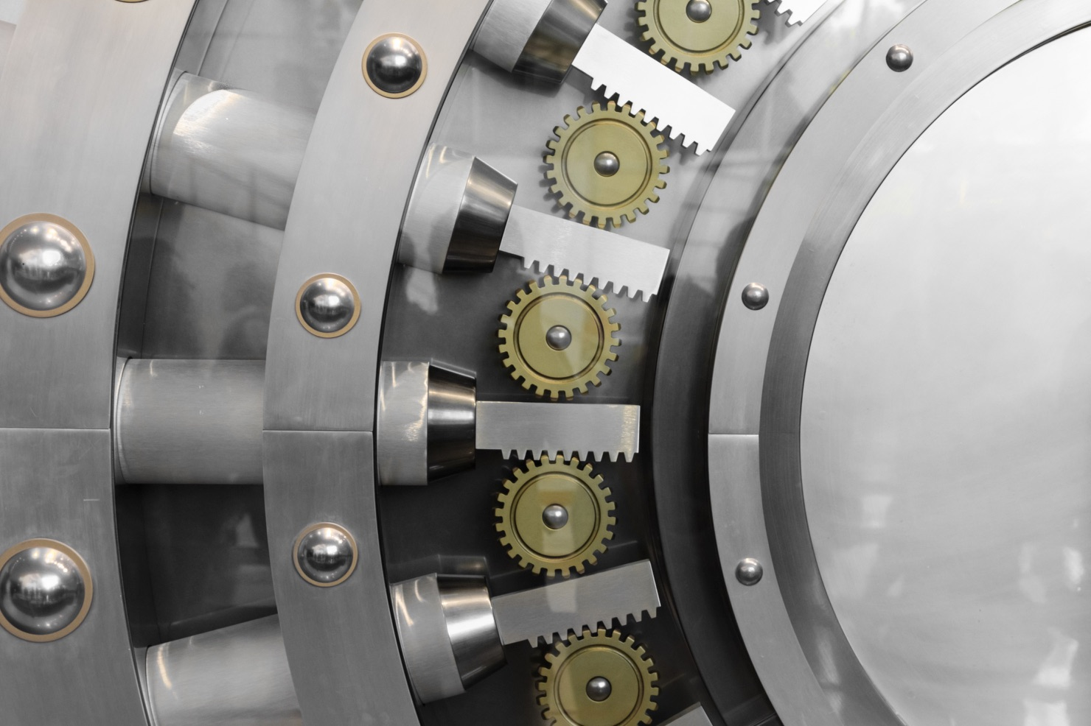compliance, and custodial solutions for blockchain-based currencies. They state that they are the largest bitcoin processor with $15 billion in transactions per month. They have more than 300 customers spread across more than 50 countries.

**Coinbase** is a digital currency exchange headquartered in San Francisco, California. They broker exchanges of Bitcoin, Bitcoin Cash, Ethereum, Ethereum Classic and Litecoin with fiat currencies in around 32 countries, and bitcoin transactions and storage in 190 countries worldwide. Coinbase has recently introduced an institutional custodial service aimed at large institutions. The new service will be focused exclusively on serving the needs of institutional clients by providing sales, sales trading, research, market operations, and client services support. We believe they will end up serving only a small segment of overall demand based on institution size, institution type, and geography. Because of our smaller size, we can act quickly and help create more customized solutions for institutions in regions Coinbase cannot cover such as areas of Europe and China.

**Xapo** is incorporated in Hong Kong, has an office in Palo Alto, California and operates Worldwide. Xapo has raised $40 million from Benchmark, Greylock Partners, Index Ventures, Fortress Investment Group, Ribbit Capital and Emergence Capital Partners. Xapo has been described by The Wall Street Journal as the Fort Knox of bitcoin storage. The Xapo wallet is available both online and offline with all transactions conducted without any fees. The main feature of the platform is their offer of a special Xapo debit card that is connected to the user’s wallet. The Xapo card allows using digital money to pay for purchases and to make withdraws without searching for available exchanges and thinking of the conversion rate of cryptocurrency to fiat money and vice versa. When replenished, the card user’s national currency is converted into the virtual currency at the current exchange rate. Also, it is possible to get some extra bonuses by using Xapo on faucet websites.

Competitive Analysis Table

| **FACTOR** | **Xxxxx** | **Fidelity Digital Asset Services** | **BitGo** | **Coinbase** | **Xapo** |
| --- | --- | --- | --- | --- | --- |
| **Products** | Custody through cold and warm storage. | Trading through multi-venue trade execution capabilities, powered by a proven order routing and matching technology.  Custody through offline, vaulted deep-cold storage. | Custody, Business Wallets, Self-storage and private blockchains. | Broker exchanges of Bitcoin, Bitcoin Cash, Ethereum, Ethereum Classic and Litecoin with fiat. Custody, Asset Management | Buy Bitcoins and act as vault for financial institutions and business. |
| **Company Reputation** |  | New to market but will be relying upon the backing of Fidelity Investments’ creditability in the market place. | Good reputation with 5 years’ experience in the market. | Founded in 2012. The company has raised $212 million from world leading investors. | Company founded in 2013. |
| **Independent Security Audits** | Yes | Unknown | Unknown | Unknown | Unknown |

***Our competitive advantage is that no other company offers exclusively institutional quality, fully insured crypto custodial services.***

### Barriers to Market Entry and Exit

**© Copyright Biztree Inc. 2010. All rights reserved. Protected by the copyright laws of the United States & Canada and by international treaties. IT IS ILLEGAL AND STRICTLY PROHIBITED TO DISTRIBUTE, PUBLISH, OFFER FOR SALE, LICENSE OR SUBLICENSE, GIVE OR DISCLOSE TO ANY OTHER PARTY, THIS PRODUCT IN HARD COPY OR DIGITAL FORM. ALL OFFENDERS WILL BE SUED IN A COURT OF LAW.**

**© Copyright Biztree Inc. 2010. All rights reserved. Protected by the copyright laws of the United States and Canada and by international treaties. IT IS ILLEGAL AND STRICTLY PROHIBITED TO DISTRIBUTE, PUBLISH, OFFER FOR SALE, LICENSE OR SUBLICENSE, GIVE OR DISCLOSE TO ANY OTHER PARTY, THIS PRODUCT IN HARD COPY OR DIGITAL FORM. ALL OFFENDERS WILL AUTOMATICALLY BE SUED IN A COURT OF LAW.**

Barriers to exit limit the ability of a firm to leave a market and can exacerbate rivalry. Examples of entry and exit barriers can be found below:

|  |  |
| --- | --- |
| **Easy to Enter if there are:**   * Common technology * Little brand loyalty * Access to distribution channels * Low scale threshold | **Difficult to Enter if there are:**   * Patented or proprietary know-how * Difficulty in brand switching * Restricted distribution channels * High scale threshold |
| **Easy to Exit if there are:**   * Salable assets * Low exit costs * Independent businesses | **Difficult to Exit if there are:**   * Specialized assets * High exit costs * Interrelated businesses |

# 4. Marketing Strategies and Sales

## 4.1 Marketing Objectives

In this section, we outline the marketing and sales strategies necessary to make our business model successful. Our marketing objectives are to:

|  |
| --- |
| 1. Develop brand awareness through a steady, month to month increase of new customers. |
| 1. To select the most effective marketing strategies that will entice the customer in a most cost-effective way that will return a significant return on investment |
| 1. To ensure that are marketing produce an effective return on investment both offline and online |

## 4.2 Targeting Strategy

Targeting strategy is aimed at high profile public companies that are adopting to crypto assets plus our strategy is to target financial institutions in the domestic and international markets who do not have the time to safeguard their crypto assets. We will target these companies and institutions by offering guarantees of safety and security that coincides with their present protocols.

## 4.3 Positioning Strategy

It is our intention to position our company as an industry leader. The positioning requires our team to be committed to consistency; plus deliver quality messaging that communicates our company’s influence. We cannot be considered an industry leader if we do not have an authentic basis for this objective. We want to ensure that our business becomes internationally recognised as a premium brand for quality products and services. In order to achieve this objective, we need to be able to:

* Incentive our team to help us to become the industry leader;
* Continue to offer quality crypto asset services to the market to meet our customers’ needs;
* Differentiating ourselves from our competitor; and
* Operate with integrity to our suppliers and customers.

## 4.4 Pricing Strategy

The pricing strategy will be simple. The pricing strategy will be based upon one percent (1%) also called 100bps of Assets Under Management “AUM” Year over Year (YOY). Assets should appreciate 2-3% a year due to growth in fiat money supply relative to fixed supply and hard coded fixed supply of crypto assets.

## 4.5 Distribution Channels

**© Copyright Biztree Inc. 2010. All rights reserved. Protected by the copyright laws of the United States & Canada and by international treaties. IT IS ILLEGAL AND STRICTLY PROHIBITED TO DISTRIBUTE, PUBLISH, OFFER FOR SALE, LICENSE OR SUBLICENSE, GIVE OR DISCLOSE TO ANY OTHER PARTY, THIS PRODUCT IN HARD COPY OR DIGITAL FORM. ALL OFFENDERS WILL BE SUED IN A COURT OF LAW.**

**© Copyright Biztree Inc. 2010. All rights reserved. Protected by the copyright laws of the United States and Canada and by international treaties. IT IS ILLEGAL AND STRICTLY PROHIBITED TO DISTRIBUTE, PUBLISH, OFFER FOR SALE, LICENSE OR SUBLICENSE, GIVE OR DISCLOSE TO ANY OTHER PARTY, THIS PRODUCT IN HARD COPY OR DIGITAL FORM. ALL OFFENDERS WILL AUTOMATICALLY BE SUED IN A COURT OF LAW.**

Our business model will operate at 100% wholesale distribution channel only for public companies and financial institutions.

## 4.6 Promotional Strategy

The promotional strategy to be adopted will comprise of a mixture of offline and online activities. These strategies are designed to reach our target customers and potential customers in a more cost-effective manner.

|  |  |
| --- | --- |
| **Offline** | **Online** |
| * Partnering with domestic business and industry groups. * Partnering with domestic financial institutions. * LinkedIn for domestic public companies. * Demonstrations of our internal systems and processes. * Free one-month trial period to ensure customer satisfaction. | * Social media platforms such as LinkedIn * Website * Videos * International partnering with business and industry groups * Partnering with international financial institutions * Demonstrations of our internal systems and processes. * Free one-month trial period to ensure customer satisfaction. |

## 4.7 Sales Forecasts

The company has prepared five-year revenue projections based upon its knowledge and expertise in the market. The five-year revenue projections are shown in the table below. As the years progress, competition in the market place will be strong and it is anticipated that revenue fee will be significantly lower than the general 1% applied now.

|  |  |  |  |  |  |
| --- | --- | --- | --- | --- | --- |
|  | **Year 1** | **Year 2** | **Year 3** | **Year 4** | **Year 5** |
| Revenue | 1,000,000 | 8,000,000 | 24,000,000 | 28,800,000 | 34,560,000 |
| Revenue Growth % |  | 700% | 200% | 20% | 20% |
| Revenue as % of AUM | 1.00% | 0.76% | 0.20% | 0.20% | 0.20% |

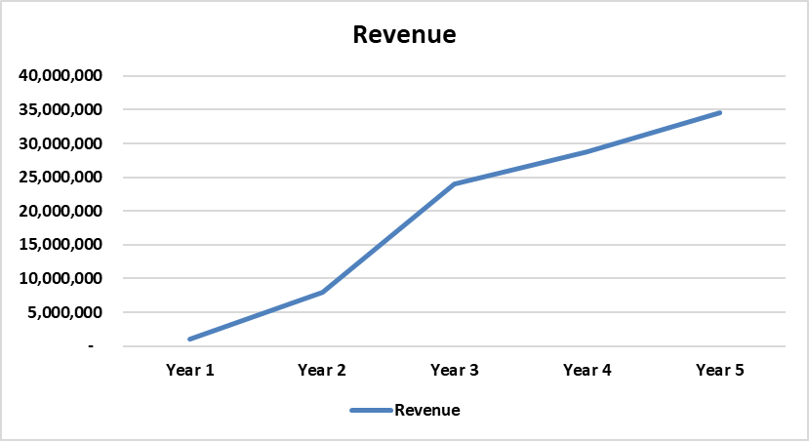

# 5. Development

## 5.1 Development Strategy

The developmental strategy takes into perspective the requirements needed to take this business into the launch mode. The company intends to start operating from 1st July 2019 or as soon as funding is received plus the granting of the regulatory approval from the Government. The regulatory approval could take up to 8 months but we would like to commence operations on xx 2019 but this will be subject to the timing for the regulatory approval.

## 5.2 Development Timeline

The following table illustrates the proposed timetable that is needed for the milestones to be accomplished.

|  |  |
| --- | --- |
| **Milestones** | **Time Frame** |
| Seeking funding | xx |
| Gaining Regulatory Approval (South Dakota Trust License) | xx |
| Obtain office space | June 2019 |
| Hire third party provider | June 2019 |
| Hire two employees | June 2019 |
| Training of employees | June 2019 |
| Marketing of Crypto Assets | June 2019 |

A close up of a logo

Description generated with very high confidenceThe hardware and software is already in place but we will keep updating both to improve operations, safety, security and efficiencies. Presently, we are utilizing TokenSoft and Knox with Ledger and a safe deposit box at Wells Fargo Bank to maintain half of the paper keys.

# 6. Management

## 6.1 Company Organization

The company will be simply structured as follows:

**Ms. xx** “Serra” is the Founder & CEO at AegisCo. Serra’s vision for AegisCo is to create a qualified custodian for institutional investors that will provide a secure and compliant way to invest into the rapidly growing multi-billion-dollar digital assets markets. The core value is to contribute to the structural foundations of the ecosystem by providing a robust digital assets custodian and asset management solutions so that the corporate and institutions can safely and securely invest in cryptocurrency.

**Mr. xx** will be the President of the Xxxxx. Mr. xx has over two decades of experience in banking and financial services and spent the last several years in the emerging Blockchain in several major Venture Capital backed firms in the space.

All other roles will be outsourced initially.

### Biography of the Team

**Ms. xx** is a pioneer in the Crypto industry, and created Serra Digital Asset Company Ltd., a Crypto Trading firm, and Serra Advisors, LP, a boutique investment banking firm that provides cross-border investments advisory and mergers and acquisitions services for clients in China and the United States. Serra Advisors, LP synergy VC/Growth Fund was evolved from the advisory model to meet the desire of Chinese companies to have a full-fledged investment partner rather than just an advisor.

Serra was a Crypto Investor for Passport Capital, and for several years prior to that was an Equity Research Analyst with Goldman Sachs for several years, where she determined technology industry research and investment guidelines: build models, perform scenario analyses and valuations, assign weight and rate stocks; maintain cooperation between regional sales and research teams. At Goldman Sachs, Serra was designated the only analyst covering Asia’s PC industry; report directly to Asia Research Head. Earned promotion to third-year analyst. Voted No.1 analyst team for PC sector by institutional investors.

Serra earned her MBA at the Stanford University Graduate School of Business, where she also earned a Certificate in Public Management and Social Innovation.

**xx**. has enjoyed the experience of many senior roles in this industry. He is well-educated through highly distinguished universities that has earned him a Juris Doctor (law degree) from the Touro Law Center in New York, an MBA from the University of San Francisco, a Bachelor’s degree from Pace University in New York City and is a Certified Anti-Money Laundering Specialist.

His two decade career has seen him serve as senior Legal, Risk and Compliance roles with Investment Advisers, Broker-Dealers, Private Equity and Venture Capital firms. Mr. xx’ experience includes helping launch one of the first fully compliant ICOs in the US, coupled with a senior leadership role in one of the oldest and largest Crypto Asset Exchanges.

He is frequently asked to speak at conferences and acts as a subject matter expert on technological solutions to risk management, governance and compliance issues within highly regulated industries.

Mr. xx’s latest venture is the recent release of his new book “Crypto Asset and ICO Governance, Risk Management and Compliance” that is published by Speakeasy Publishing.

## 6.2 Professional Advisors

The company has a range of professional advisors who will help the business during the start-up and growth stage of the business. The list of professional advisors is shown below.

|  |  |
| --- | --- |
| **Position** | **Name** |
| Directors | Five directors to be advised |
| Shareholders | xx |
| Professional Advisors | TBA |
| Banker | Silvergate (San Diego) |
| Accountant | Richey May & Co |
| Lawyer | Dechert (LA and London) |

# 7. Operations

## 7.1 Operations Strategy

The operational strategies are designed to ensure that we can deliver a safe and secure environment for which our customers entrust us to deliver. The strategies are designed so that our operations are fully compliant at all times.

## 7.2 Personnel

**© Copyright Biztree Inc. 2010. All rights reserved. Protected by the copyright laws of the United States & Canada and by international treaties. IT IS ILLEGAL AND STRICTLY PROHIBITED TO DISTRIBUTE, PUBLISH, OFFER FOR SALE, LICENSE OR SUBLICENSE, GIVE OR DISCLOSE TO ANY OTHER PARTY, THIS PRODUCT IN HARD COPY OR DIGITAL FORM. ALL OFFENDERS WILL BE SUED IN A COURT OF LAW.**

**© Copyright Biztree Inc. 2010. All rights reserved. Protected by the copyright laws of the United States and Canada and by international treaties. IT IS ILLEGAL AND STRICTLY PROHIBITED TO DISTRIBUTE, PUBLISH, OFFER FOR SALE, LICENSE OR SUBLICENSE, GIVE OR DISCLOSE TO ANY OTHER PARTY, THIS PRODUCT IN HARD COPY OR DIGITAL FORM. ALL OFFENDERS WILL AUTOMATICALLY BE SUED IN A COURT OF LAW.**

At this stage only two personnel will be employed by the business. The personnel will be paid above award wages so as to compensate for their skills and experience in the industry. The staff will undergo internal induction training and on-going training as required. The remainder of the job functions will be outsourced until such time as we feel it warrants bringing the roles in-house.

## 7.3 Risk Management

It is important to identify and manage risks and potential risks on a regular basis. Managing risk will be a key component of our business model, and we are already in the process of identifying all risks and setting into place the appropriate internal control processes and procedures that are necessary to minimize risk.

The risks that we have identified thus far include:

**Cyberisks.** The nature of cryptocurrency makes it highly vulnerable to hacks, data leaks, and theft. Many of the biggest hackings in crypto-exchanges were due to mismanaged human assets, specifically employees involved in coding the system. Hacking can occur anywhere and anytime through our employees, internal processes, our software and hardware. We will be minimizing these risks by adhering to best practice in people and processes. Implementing sound testing policies, conducting regular and rigor independent audits and testing, and ensuring the best security team and advisors are in place to tackle this challenge, will be key for our success.

**Market risks** linked to daily price volatility and rapidly fluctuating volumes also exists, mostly due to unstable market psychology, an immature market dynamic, and constantly changing regulations.

**Pricing risk** as data sources from exchanges are volatile and not easily verifiable, and certain exchanges have been exposed as being slow or even failing in making payments in a timely manner. This all makes direct trading for our clients difficult and risky to execute. We aim to reduce these risks by developing a record of our transactions and analyzing trades against benchmarks in the market.

**Counterparty risks**. The counterparties we trade with might be hacked, have their assets taken, or shut down by a regulating body. We will build appropriate processes to minimize these risks, including monitoring news and developments, developing internal monitoring systems to analyze liquidity conditions and news, communicating with market makers on a regular basis, working to establish good connections with regulating authorities, and other activities that might help us reduce counterparty risks

## 7.4 Operations Expenses

The following chart illustrates the operational expenses that the company projects to incur over the next five years.



## 7.5 Legal Environment

The two major issues that the company faces are (a) obtaining the funding required for Net Capital and (b) gaining Regulatory Approval.

South Dakota has modern trust laws that protect the safeguarding of assets and the legal rights of the beneficiaries, while being progressive enough to accommodate crypto assets. In other words, the laws and politics in South Dakota appear to be progressive in a way that facilitates property rights and free market capitalism. South Dakota has revolutionized trust formation and administration in the United States and offers tremendous control and flexibility to the international and institutional clients.

According to the National Conference of State Legislatures, the CRYPTOCURRENCY 2018 LEGISLATION does not apply to South Dakota as at 5th July 2018. [5] This legislation applies to North Dakota and could soon be in force in South Dakota.

# 8. Financials

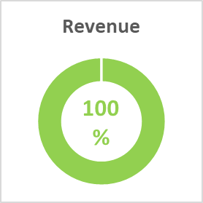In this section, the company illustrates the financial projections that have been prepared based upon its knowledge of the industry, market and experience. The financial projections reflect a conservative growth each year.

## 8.1 Financial Summary

**Highlights**

* Fifth year revenue to reach $xx million based upon Assets Under Management of $xx billion.
* Net profit before tax of 74% in fifth year.
* Return on Investment after dividends = 124%
* Strong cash position by end of fifth year of $44.5 million.

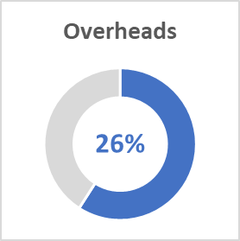**Assumptions**

* As the business grows, overheads are projected to increase by 20% per annum.
* Revenue service fee is expected to decline in future years due to heavy competition in the market place.

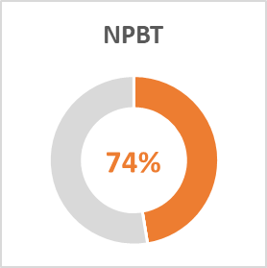

## 8.2 Key Performance Indicators

**© Copyright Biztree Inc. 2010. All rights reserved. Protected by the copyright laws of the United States and Canada and by international treaties. IT IS ILLEGAL AND STRICTLY PROHIBITED TO DISTRIBUTE, PUBLISH, OFFER FOR SALE, LICENSE OR SUBLICENSE, GIVE OR DISCLOSE TO ANY OTHER PARTY, THIS PRODUCT IN HARD COPY OR DIGITAL FORM. ALL OFFENDERS WILL AUTOMATICALLY BE SUED IN A COURT OF LAW.**

**© Copyright Biztree Inc. 2010. All rights reserved. Protected by the copyright laws of the United States & Canada and by international treaties. IT IS ILLEGAL AND STRICTLY PROHIBITED TO DISTRIBUTE, PUBLISH, OFFER FOR SALE, LICENSE OR SUBLICENSE, GIVE OR DISCLOSE TO ANY OTHER PARTY, THIS PRODUCT IN HARD COPY OR DIGITAL FORM. ALL OFFENDERS WILL BE SUED IN A COURT OF LAW.**

KPIs, or key performance indicators, can help you understand if you are on the right track for success—and if not, where to focus your attention. No matter what it measures, the aim of any KPI is to bring about improvement. The following table illustrates the key metrics that it should adopt into its business model to be reviewed on a regular basis.

## 8.3 Key Ratios

## 8.4 Start-up Funds

The company requires funding to the value of US$xx,000,000. The funding acquired will be spent on the following items:

## 8.5 Statement of Financial Position (Balance Sheet)

**© Copyright Biztree Inc. 2010. All rights reserved. Protected by the copyright laws of the United States and Canada and by international treaties. IT IS ILLEGAL AND STRICTLY PROHIBITED TO DISTRIBUTE, PUBLISH, OFFER FOR SALE, LICENSE OR SUBLICENSE, GIVE OR DISCLOSE TO ANY OTHER PARTY, THIS PRODUCT IN HARD COPY OR DIGITAL FORM. ALL OFFENDERS WILL AUTOMATICALLY BE SUED IN A COURT OF LAW.**

**© Copyright Biztree Inc. 2010. All rights reserved. Protected by the copyright laws of the United States & Canada and by international treaties. IT IS ILLEGAL AND STRICTLY PROHIBITED TO DISTRIBUTE, PUBLISH, OFFER FOR SALE, LICENSE OR SUBLICENSE, GIVE OR DISCLOSE TO ANY OTHER PARTY, THIS PRODUCT IN HARD COPY OR DIGITAL FORM. ALL OFFENDERS WILL BE SUED IN A COURT OF LAW.**

The company has prepared its projected Balance Sheet based upon its belief of the financial position throughout each of the next five years. The Balance Sheets highlights the Assets, Liabilities and Equity of the business at any given point in time.

## 8.6 Income Statement

The Income Statement, also known as Profit & Loss Statement, highlights the revenues generated by the business less the operational expenses. The company has prepared revenue and expense projections based upon its knowledge of the industry.

## 8.7 Statement of Cash Flows

The Statement of Cash Flows records the movement of cash into and out of the business over a certain time period. The movement in Cash Flow will differ from what is shown in the Income Statement due to taking into account items shown in Balance Sheet such capital expenditures, taxes and dividends.

Cash Flows generated from operations are healthy and strong giving the business the opportunity for an early exit or future business acquisitions. Operational cash flows are sufficient for dividend payout, repayment of the loan within five years and future capital expenditures.

# 9. Funding Request

## 9.1 Offer

The directors of the business present to you its offer to join the company and be part of the team.

|  |  |
| --- | --- |
| **PROJECT INFORMATION** | |
| **Project title** | **Crypto Asset Storage** |
| **Date of submission** | **1st November 2018** |
| **Total amount requested** | **US$xx,000,000** |
| **Expected start date** |  |
| **Expected completion date** |  |
|  | |

## 9.2 Capital Requirements

The company foresees that equity will need to be injected into the business to allow for the commencement of the business. Funding requirements of **US$xx million** will be required initially to commence the business model.

Our invitation is extended to an individual shareholder or groups of 5 or 10 shareholders as shown in the table below.

|  |  |  |
| --- | --- | --- |
| **Invitation** | **% Equity each shareholder** | **% of dividends each shareholder paid out of after-tax profits** |
| 1 Shareholder | 75% | 30% |
| 5 Shareholders | 15% | 6% |
| 10 Shareholders | 7.5% | 3% |

## 9.3 Valuation of Business

The business can be valued in many ways**.** Typically, this style of business would be valued on earnings multiple (usually xx to xx times). The earnings multiple can vary from year depending upon various many external variable such as economy and market conditions. The valuations that are shown in the media are widely different. For example, Nividia is reportedly reflected as 53 earnings multiplier.

As an example, we will illustrate an example of a business valuation, but it must be noted that market and economic conditions can change this valuation at any time. The projected valuation is based upon the fifth year financial projection.

**Net profit before tax is projected to be xxxx.**

**Add back owner’s salary of xxxx**

**Adjusted net profit before tax = xxxx**

**Earnings multiple of XX would value the business at xxxx**

**Earnings multiple of XX would value the business xxxx**

## 9.4 Exit Strategy

The company has no immediate plans for exiting. The company plans to be still trading in ten years’ time allowing it the opportunity to expand its business model into other locations across the country. The strength of the Balance Sheet will allow the business to be in a strong position for takeover, seeking further funding or for the director to exit the business. The exit strategies to be considered will include:

* **Mergers and Acquisitions -**With a merger or acquisition, the owner of the business can sell the controlling interest in the business to another party but may still assume a smaller role in the day-to-day operation. This strategy will only be considered if the shareholders wish to leave the business gradually without selling it outright.
* **IPO -**An Initial Public Offering (IPO) occurs when a privately-owned business decides to sell shares of stock to the public. This can be highly profitable for the business after it has been fully developed, as this can generate a large amount of revenue in a short period of time. IPOs are often issued by smaller, younger companies seeking capital to expand, but they can also be done by large privately owned companies looking to become publicly traded. In an IPO, the issuer obtains the assistance of an underwriting firm, which helps determine what type of security to issue, the best offering price, the amount of shares to be issued and the time to bring it to market.

1. Source – BABB - https://medium.com/babb/what-is-a-crypto-asset-1f0fcc517887
2. Source – Financial Stability Board - FSB report sets out framework to monitor crypto-asset markets 16/07/2018
3. Source – Crypto Fund Research - https://cryptofundresearch.com/cryptocurrency-funds-overview-infographic/
4. Source – Statista 2018
5. Source - National Conference of State Legislatures - http://www.ncsl.org/research/financial-services-and-commerce/cryptocurrency-2018-legislation.aspx