Feasibility Study
Health Industry App
for Saudi Arabia Market
[2016]

Contents
1. Executive Summary 3
2. Introduction 3
2.1. Purpose 3
2.2. Project Description 3
2.3. Target Audience 4
2.4. Impact of Social Media, SmartPhones and Androids 5
3. Justification 6
3.1. Problem Statement 6
3.2. Solution Objectives 7
4. Solution 8
5. Alternatives 9
6. Cost Benefit Analysis 11
7. Development and Creation of Mobile App 12
8. Financial Projections 14

Executive Summary

This Feasibility Study is needed to demonstrate the requirement and the viability of improving health services to all people residing in the Kingdom of Saudi Arabia. This Study outlines a solution to solve one of the many issues faced by the Ministry of Health and its patients. The solution provided will help bridge the gap between the health industry and patients whilst offering substantial financial and social benefits.

Two models have been proposed within this Study. The first model is to attract health professionals/organisations and customers to take advantage of the mobile app on a monthly subscription base. The second model is go one step further – to allow the same organisations to sale prescriptions and medical equipment online. The additional revenue to us would be US$1 processing fee per transaction.

Introduction

Purpose

The purpose of this Feasibility Study is to undertake a review of introducing a unique mobile app that will assist the many health organisations and professionals in the Kingdom of Saudi Arabia plus equally important, the consumer. This report will only be considering Stage 1 of project which is outlined below.

Consumers in the Kingdom of Saudi Arabia are becoming more conscious about their health. As a consequence, the idea that is presented in this Study identifies a solution to an on-going problem that is not currently being faced in the country.

Many medicines are available from pharmacies without prescription, including some that require a prescription in most western countries, like antibiotics. On the other hand, some medicines that can be bought over the counter in other countries require a prescription in Saudi Arabia. Presently, there is no system in place to help or to monitor patient medication.

Project Description

This project will become a two stage project that is to be developed over the next two years.

Stage 1 – Design and development a mobile app that will help the consumer plus health professionals to monitor and measure patient prescribed medication.

Stage 2 – To bring online medical resources to the consumer, particularly in rural areas where they have limited access.

Target Audience

Saudi Arabia is geographically the fifth largest state in Asia and second largest state in the Arab world (after Algeria). Saudi Arabia is bordered by Jordan and Iraq to the north, Kuwait to the northeast, Qatar, Bahrain, and the United Arab Emirates to the east, Oman to the southeast, and Yemen to the south. It is the only nation with both a Red Sea coast and a Persian Gulf coast, and most of its terrain consists of arid inhospitable desert or barren landforms.

According to CountryMeters.com, the estimated population of Saudi Arabia on 2nd June 2016 was shown as:

NUMBER | DETAILS
32 239 760 | Current population
17 802 150 | Current male population (55.2%)
14 437 610 | Current female population (44.8%)

It is quoted from the same source that the population is growing at 300,000 people per annum and by the year 2020, the population is expected to touch 34,000,000.

The population is divided among different age groups. The 0-14 age group contains the median amount of the population, comprising 32.4% of the total. The middle age group of 15-64 makes up the greatest share of the total population - about 64.8%. The 65+ age group comprises 2.8% of the total population.

The sex ratio at the time of birth is 1.05 males per female. For the under-15 age group, this ratio is 1.04 males per female; for the 15-64 age group, it is 1.03 males per female; and for the 65+ age group, it is 1.03 males per female. For the total population, the mean ratio is 1.37 males per female.

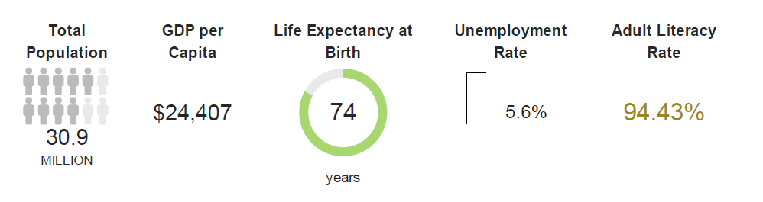
Our key target audience is to reach communities in outer city areas (rural) and those people who are elderly or house-bound. However, the solution provided would be available for anyone who has access to the internet through Desktop, Smartphone or Android.

Impact of Social Media, SmartPhones and Androids

It is important to include a section on social media in this report as the project will rely heavily on the use of social media as the platform for delivery and marketing of our solution.

Social media is becoming a popular media platform that the Saudi Arabians have grasped with pleasure. Saudi Arabia ranks number seven globally in terms of individual accounts on social media. This was revealed in a survey by Saudi Aramco, which was based on official statistics from social media websites.

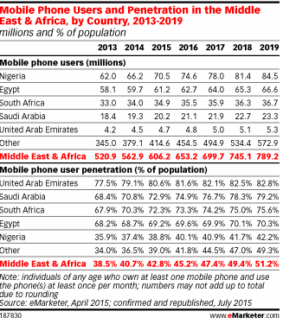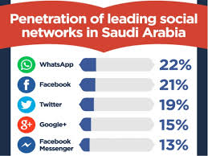It is important to note that even though social media is used by a large proportion of the SA population, the statistics below tell how and where we can market our mobile appl. It is critically important that we can launch our mobile app on to technology based SmartPhones and Androids but to attract the various age demographics.

Smartphone adoption and its influence in the lives of people, continues to grow at an exponential rate. In Saudi Arabia, a staggering 67 percent of the population above 16 years use a smartphone according to a recent study from Nielsen, a leading global provider of information and insights into what consumers watch and buy. This percentage is even higher among Youth (73%) and with a large population under the age of 15, Saudi Arabia will remain a key growth market for smartphone makers.

Justification

This section highlights the problems faced by patients in Saudi Arabia. Justification and highlighting the issues raised will lead us to illustrate that our solution is an affordable and effective solution.

Problem Statement

The health care system in Saudi Arabia can be classified as a national health care system in which the government provides health care services through a number of government agencies. In the meantime, there is a growing role and increased participation from the private sector in the provision of health care services.

The Ministry of Health (MOH) is the major government agency entrusted with the provision of preventive, curative and rehabilitative health care for the Kingdom’s population. The Ministry provides primary health care (PHC) services through a network of health care centers (comprising 1,925 centers) throughout the kingdom. It also adopts the referral system which provides curative care for all members of society from the level of general practitioners at health centers to advanced technology specialist curative services through a broad base of general and specialist hospitals (220 hospitals).

Obesity, diabetes, high blood pressure, high cholesterol, and smoking are among the leading issues that affect a growing number of people in Saudi Arabia, according to a survey by the Kingdom of Saudi Arabia and the Institute for Health Metrics and Evaluation (IHME) at the University of Washington.

The Saudi Health Interview Survey covers all 13 regions of the Kingdom of Saudi Arabia and uses a representative sample of adults aged 15 and older. The survey highlighted the following issues (sample of many of the medical issues raised in the survey):

- The prevalence of obesity was 28.7%. It was higher among females than males, 33.5% and 24.1%, respectively. The prevalence increased by age and was highest among those aged 55 to 64, with levels of 48.0%.
- Almost half of women are physically inactive, while 29% had low levels of physical activity. For men, 23% are physically inactive, and the same percentage had low levels of physical activity.
- The total prevalence of diabetes was 14.8% for males and 11.7% for females in 2013. It increased with age and ranged from 7.8% among those aged 25 to 34 to 50.4% among those aged 65 and older. Borderline diabetes was present in 17% (1.17 million) of men and 15.5% (0.95 million) of women. Among Saudi men, 1 million are diabetic, 583,000 are on medication for diabetes, and 230,000 have uncontrolled diabetes. For women, 720,000 are diabetic, and 367,000 are on medication, while 167,000 have uncontrolled diabetes.
- The prevalence of hypercholesterolemia was 9.5% for males and 7.3% for females. It increased by age and was highest among those aged 65 or older (28.7%). About 658,000 Saudi men and 448,000 Saudi women are hypercholesterolemic. Borderline hypercholesterolemia was found in 19.5% (1.25 million) of men and 20.6% (1.18 million) of women. Almost 215,000 men and 116,000 women are on medication, but only 7.4% of them have uncontrolled hypercholesterolemia.

The above four points highlight only some of the health issues facing the people of Saudi Arabia.

Regardless of medical conditions, people of Saudi Arabia require prescribed medications. Medications are prescribed by hospitals, doctors, medical centres and other professional places typically done by paper or electronic scripts. The patient fills the prescription at recognized pharmacies and drug stores. However, there is no direct link between ensuring that the patient takes the right dosage at the required levels or reminders to refill prescribed medication where applicable.

As healthcare organizations and the consumers that they serve seek best practices for personalized communication programs to achieve better health, one challenging area is the difference between the number of medications prescribed by medical practitioners and the subsequent fulfillment rates for those prescriptions by their patients.

For patients, deciding not to pick up and pay for a prescription can often be attributed to potential cost concerns, concerns about drug side-effects, or even doubts about if the medication will actually work.

Solution Objectives

The objectives of finding a solution to the issues raised above are focused on better quality health management for the patient whilst enhancing better delivery, technical process, improved quality standards for the health industry.

To find the solution, we need to discover a direct connection between the patient and the various health organisations/professional with strong focus on our target audience.

Solution

The solution that is in the process of being conceived is the development of a mobile app that will be the solution for the above mentioned problem. The name of the mobile app is most likely to be called:

XXXXXX

The consumer will be able to download the mobile application on to their Smartphone or Android free of charge. The solution will be linked into all medical centres, hospitals, pharmacies and doctors.
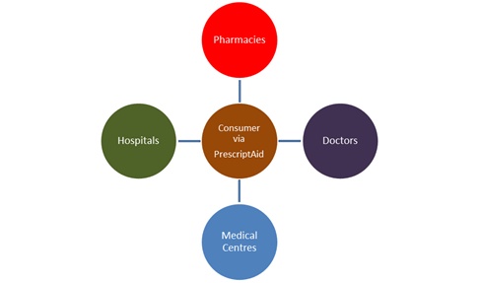

The mobile app will be a two way relationship between the respective health professionals/organisations and the consumer.
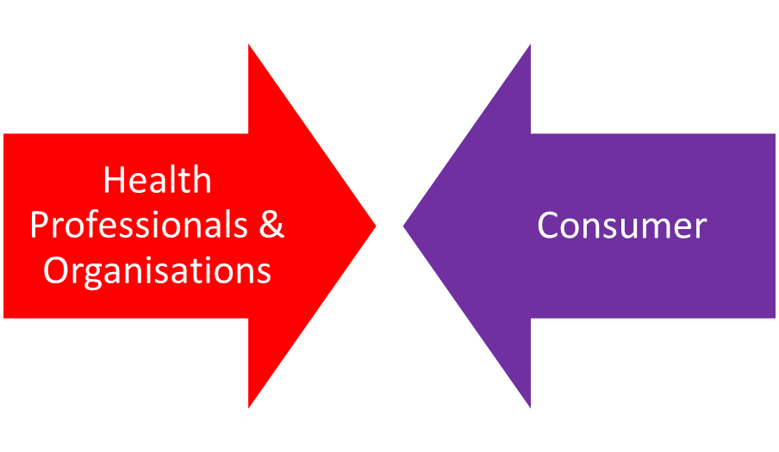

Health Professionals/Organisations

The various health professionals and organisations who will participate in this mobile app will be able to offer a lot of key features to the consumer. The mobile app will contain the following features:

- Medicine reminder to each patient as to when and how to take their prescribed medication
- Dosage verification with each consumer on the number of tablets or millilitres of syrup to be taken.
- Online monitoring and editing. The patient will confirm the above information within the mobile application so that history can be kept by both the patient and the responsible health professional or organisation.
- Reminder to patients to re-order their prescribed medication prior to medication running low
- The ability to offer more medical products (rather than just prescribed medication) and services outside of the medication theme.
- Available to patients 24/7
- Available to city and rural areas providing there is excellent internet technology.

Consumers

The benefits to the consumer are enormous as identified below:

- Mobile app is Free of Charge
- Available 24/7 subject to consumer’ internet connection
- Patients will be able to keep track of their history
- Patients will be able to renew prescriptions online (subject to conditions and approval regulated by the health professional or organization)
- Patients will be able to discuss side effects issues with their respective health organization.
- Ability to purchase all medical products and services without the requirement to leave their home.

Alternatives

There are no solutions available in the Kingdom of Saudi Arabia that will help both the medical profession and the patient.

However, there are similar medical apps available for patients but these are not necessarily available for the people of Saudi Arabia.

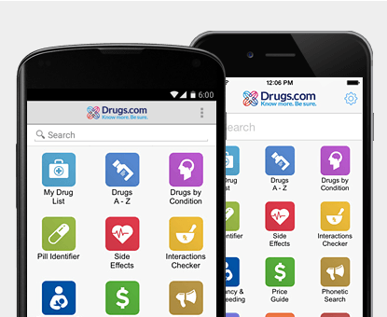Drugs.Com - The easiest way to lookup drug information, identify pills, check interactions and set up your own personal medication records. The Pill Identifier App is a searchable database of pill images which includes more than 14,000 Rx/OTC medications found in the U.S. You can search based on imprint, drug name, color and shape.

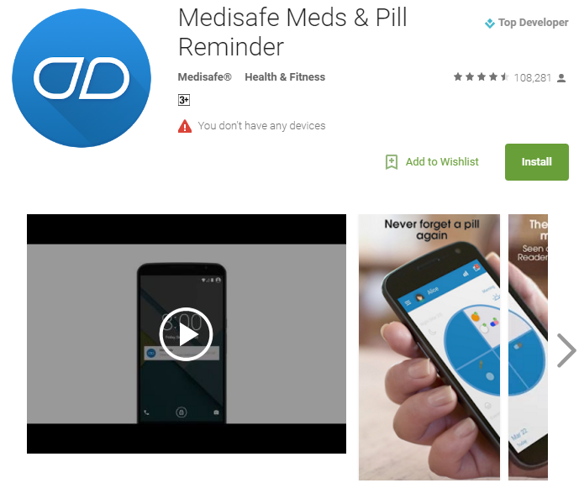

Medisafe is similar style mobile app. Millions use Medisafe to stay safe with their meds and keep track of blood pressure, glucose and other measurements. With Medisafe you can easily share results with doctors to track better outcomes, faster.

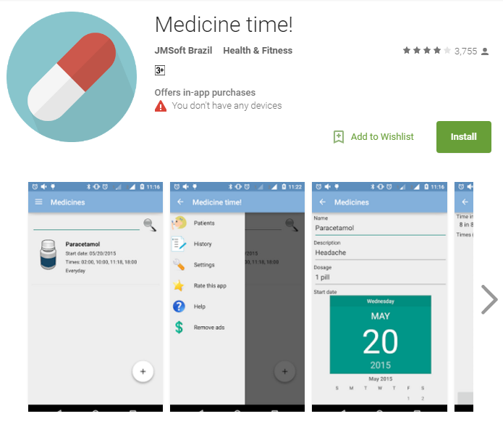
The final mobile app selected is called “Medicine Time”. With this app, taking medicine will be much easier!
Don't ever forget your medicines again, download this app and let it remembers you!
You may set a variety of different times for different days! The medicine may be continuous or not.
You can set the sound for notification too!

Cost Benefit Analysis

In this section, the cost benefit analysis is studied for this project.

Apart from the typical monetary benefits, there are social benefits (intangible) available to the consumer and the professional health organisations. Mobile apps improve medication adherence and reduce costs.

As healthcare organizations and the consumers that they serve seek best practices for personalized communication programs to achieve better health, one challenging area is the difference between the number of medications prescribed by medical practitioners and the subsequent fulfillment rates for those prescriptions by their patients.

For patients, deciding not to pick up and pay for a prescription can often be attributed to potential cost concerns, concerns about drug side-effects, or even doubts about if the medication will actually work.

A study by the American College of Preventive Medicine noted that for every 100 prescriptions written, 50 to 70 are actually picked up and paid for at the pharmacy, 25 to 30 are taken properly, and only 15 to 20 are refilled as prescribed. The same study also noted that while overall satisfaction of care is not typically a factor in medication adherence, the level of adherence does drop when there are long lapses between appointments or communication with their healthcare professional.

An additional barrier for consumers related to prescription adherence can be restrictions placed on medications by healthcare plans. Surveys indicate that upwards of 40% of patients who receive a prior authorization request for the prescribed medication are likely to neglect treatment altogether, which often can lead to a decrease in the patients’ long term health prognosis and additional financial burdens.

Healthcare organizations that provide more streamlined medication prior authorization support, personalized mobile pharmacy benefit applications and patient portals, can improve their rates of overall prescription adherence.

Integrated messaging platforms that access a member’s preferred communication channel—be it texting, email, print or phone call reminders—are most likely to improve prescription adherence rates, which in turn lowers costs for the patient, the patient’s employer and the health plan and government payers who might ultimately be at risk for the total cost of patient care.

We have discussed the social benefits thus far. Now to review the financial benefits.

The financial benefits attributable to this project are many outside of the initial up-front costs. Section 8 outlines the positive cash flows if the mobile app is owned by an outside organization based upon the assumption that health professionals will want to participate in the mobile appl. For a small monthly fee for each health professional to participate as members, can reap significant benefit the outside organization. Health professionals will reduce internal administrative costs.

However, if the mobile app was developed by the Ministry of Health, the financial projections shown in Section 8 highlight the costs attributable up-front and on-going.

Development and Creation of Mobile App

What does it cost to develop a mobile app? That’s a lot like asking how much does it cost to buy a car or build a house – it depends on what kind of car you’re buying or house you’re building.

The only sure way to find out what it will cost to get your app idea developed is to get some quotes from experienced app developers. They can discuss the details of your idea with you and give you a pretty good idea of what it will cost. Getting three quotes is helpful as it will give you an idea if a quote is too high (or too low, which can be just as bad).
Several mobile app and platform companies are now offering calculators that let you specify the features you need and see a ballpark estimate of how much your app will cost.

An example cost of developing a mobile app is shown below.
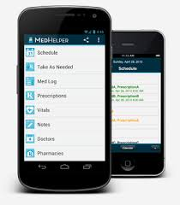
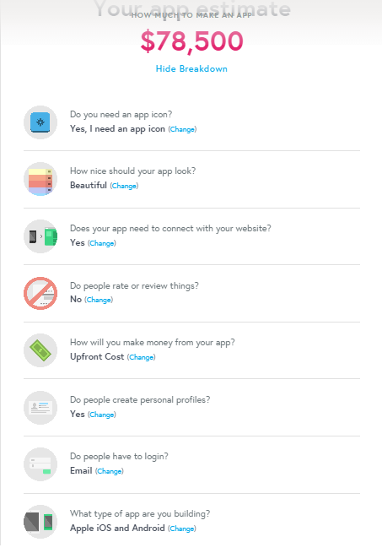

Source - http://howmuchtomakeanapp.com/

Another quote taken from WASP, identifies similar type of cost for development of a mobile application.

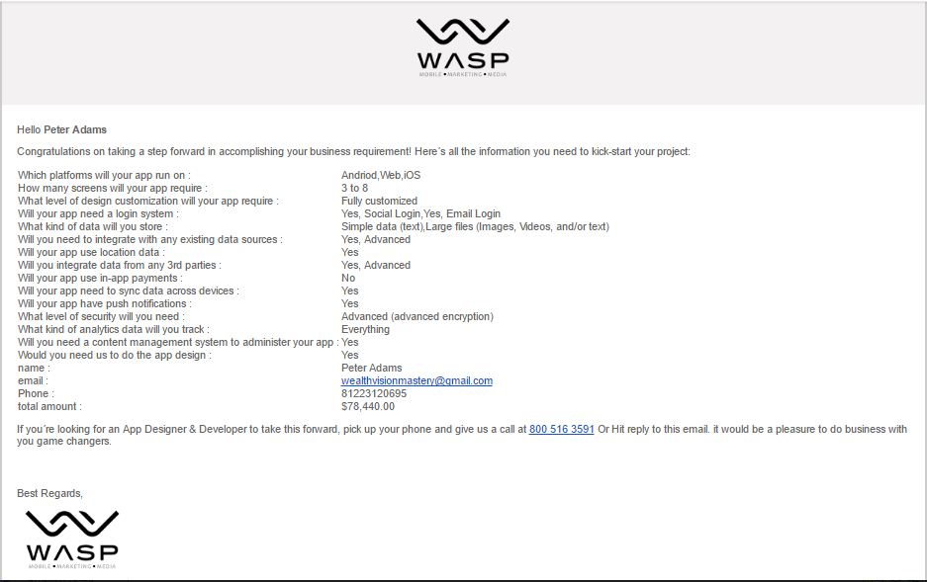

Please note that these are estimate costs. However, a full itemized quote including design will need to be obtained. Depending upon the specific requirements need for the app, coupled with the features and level of security can significantly alter this price.

If the mobile application is to include the opportunity for its customers to purchase product, then the cost of development will be higher – projected to be $84,700.

Financial Projections

Initial financial projections can prove this mobile application to be a viable application. However, further research will need to be done.

We present two models for consideration:

Model 1 – Subscription Based Method for Health Professionals/Organisations

And

Model 2 – Sale of Ancillary Products/Services by Health Professionals/Organisations

______________________________________________________________________________

Model 1 – Subscription Based Method for Health Professionals/Organisations

This simple model is focused upon solving the problems that have been raised earlier in this Study through the Health Professionals/Organisations subscribing to your mobile application for the intended use as already defined.

Our comments are as follows:

- Cost of development of mobile app needs to be confirmed
- Estimation of number of participants would need to be verified
- Allowance has been made for marketing the app
- A proposed development royalty fee of 10% payable quarterly
- Subscription to be paid at $20 per month per subscriber

Model 2 – Sale of Ancillary Products/Services by Health Professionals/Organisations

This model is an extension of the first model with projections included for transaction fees for introducing the opportunity of in app purchases. The Health Professionals/Organisations and Insurance Companies would be able to encourage their customers to buy prescription medication and medical equipment through this mobile app and the business would get a US$1 processing fee. Credit card fees have not been allowed for in this study

Our comments are as follows:

- Cost of development of mobile app needs to be confirmed as this cost now includes in app purchase feature for prescription purchase and medical equipment
- Estimation of number of participants would need to be verified
- Allowance has been made for marketing the app
- Health professionals/organisations could advertise (not included in Study)
- A proposed development royalty fee of 10% payable quarterly
- Subscription to be paid at $20 per month per subscriber

